**How To Change Your Password**

*You must be at the office or connected to the vpn before you can change your password.*

* Press Ctrl + Alt + Delete on your keyboard.
* 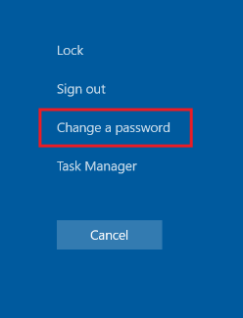Select “Change a password”.
* Enter your current password, new password.
* 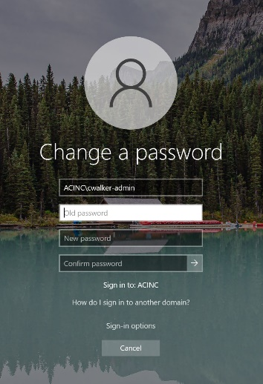Press Enter or click the Arrow in the “Confirm password" box.

**New Password Requirements:**

* Password must not contain the user's account name or more than two consecutive characters from the user's full name.
* Password must be ten (10) or more characters long.
* Password must contain characters from three of the following four categories:
  + Uppercase letters (A-Z)
  + Lowercase letters (a-z)
  + Numbers (0-9)
  + Non-alphanumeric characters (!, $, #, %, etc.)